|  |  |  |  |  |  |
| --- | --- | --- | --- | --- | --- |
| Date | November 29,2022 | | | Tester Name | Shahabuddin Syed |
| Environment | Penfax - Test | | | Login used |  |
| Operating System | Windows | Version: | Update: | | |
| Software Used | Edge | Version: | Update: | | |
| Select Software | Version: | Update: | | |
| Release version | 22.4.1 | | | | |
| Title | E22.01 | | | | |
| Test Type | Regression | | | | |
| Test Scenario | Process a SPAF quote (for PEPP member)  Scenario 1: Joint PEPP member with retirement date in future  Scenario 2: Single PEPP member using override account balance field | | | | |
|  |  | | | | |
| Expected Results | The quote will process, the letter will show the information correctly. That interest will generate from today’s date to the retirement date based on the rate of return entered.   That the payment amount for the annuity seems reasonable *(*currently no way to verify these amounts)*  That the quote saves both on Penfax in DC calculation history and in the communications tab, and that member can view this information in PENWEB. | | | | |
| Pass/Fail | Pass | | | JIRA# | N/A |

Started a DC benefit calculation. Entered in estimated retirement date (and termination date with the same date).

Entered in Rate of Return & clicked calculate.

**Scenario 1: Joint PEPP member & future retirement date**

SID: 267827

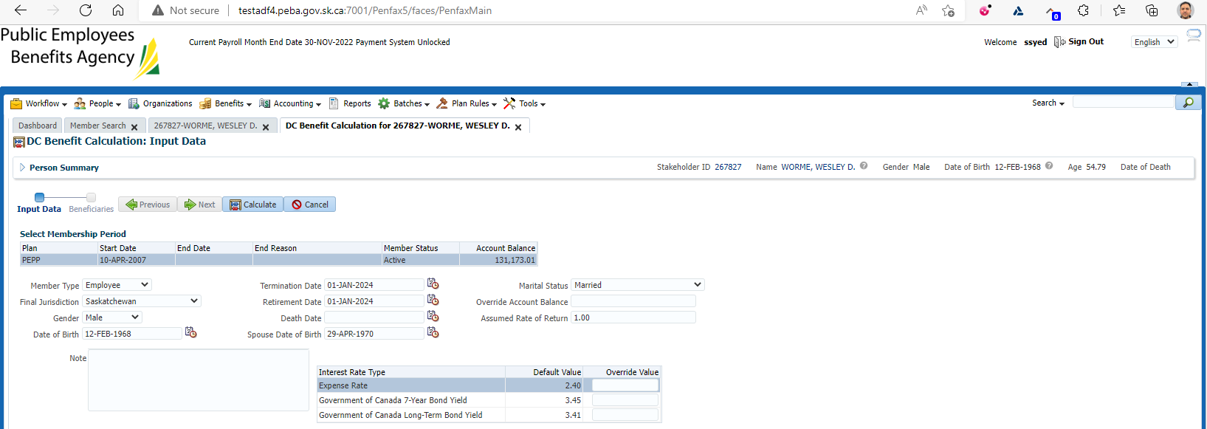

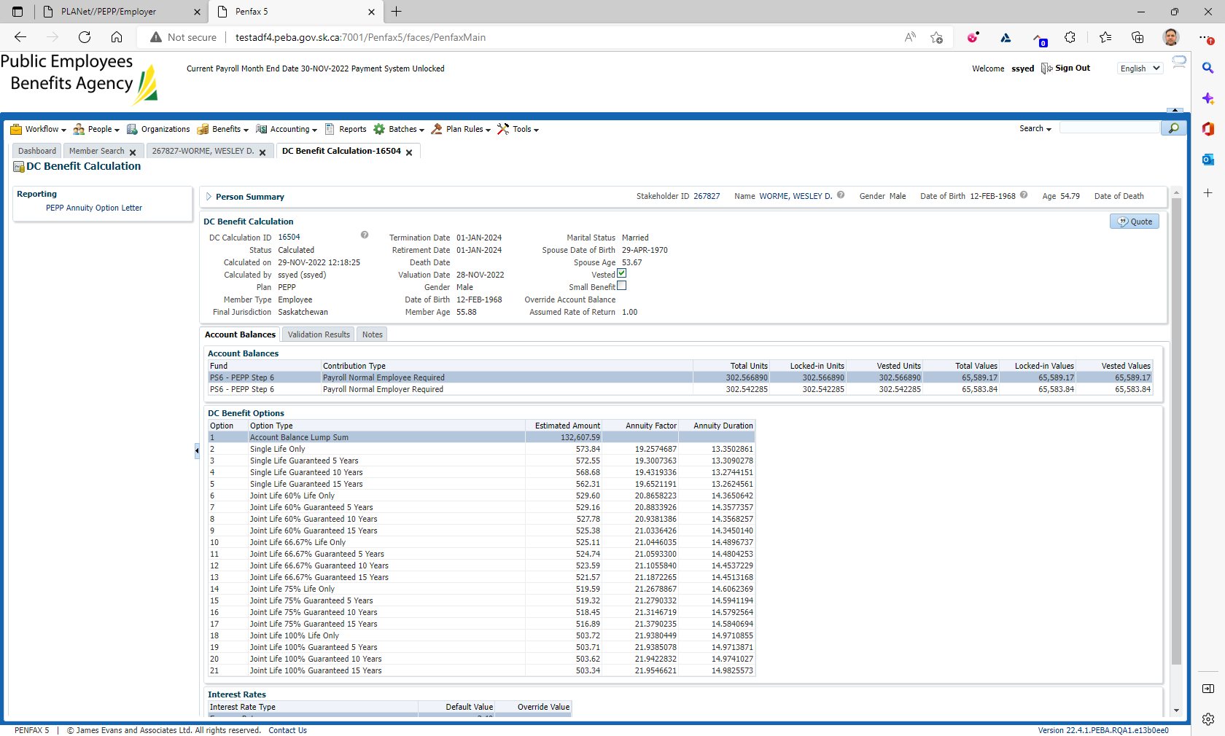

Added the account balance to confirm today’s balance:

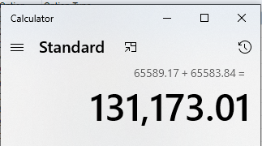

Confirmed that the amount used in the annuity quote, 132,607.59 isn’t the same which would have accounted for the 1% interest.

Used account projection calculator to confirm interest calculation.

H:\Pension Programs\PEPP\Templates and Forms\Retirement\Account Balance Projection Calculator

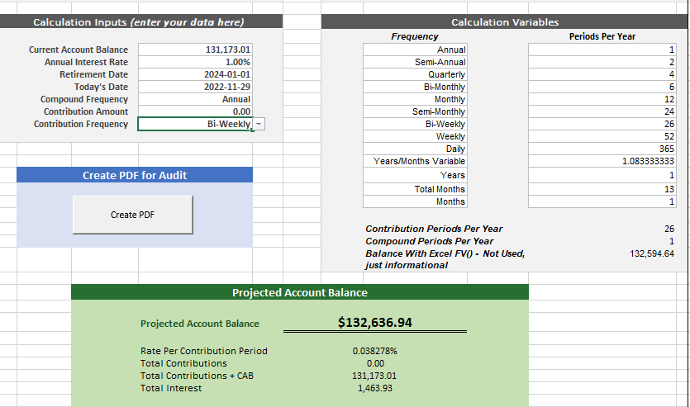

Confirmed projection amount is reasonable in Penfax compared to projection calculator.

Checked that the correct amounts populated on the letter;

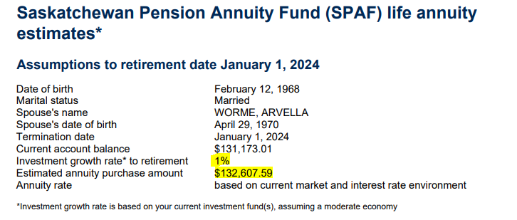

Clicked Quote on Penfax & confirmed that the letter was saved.

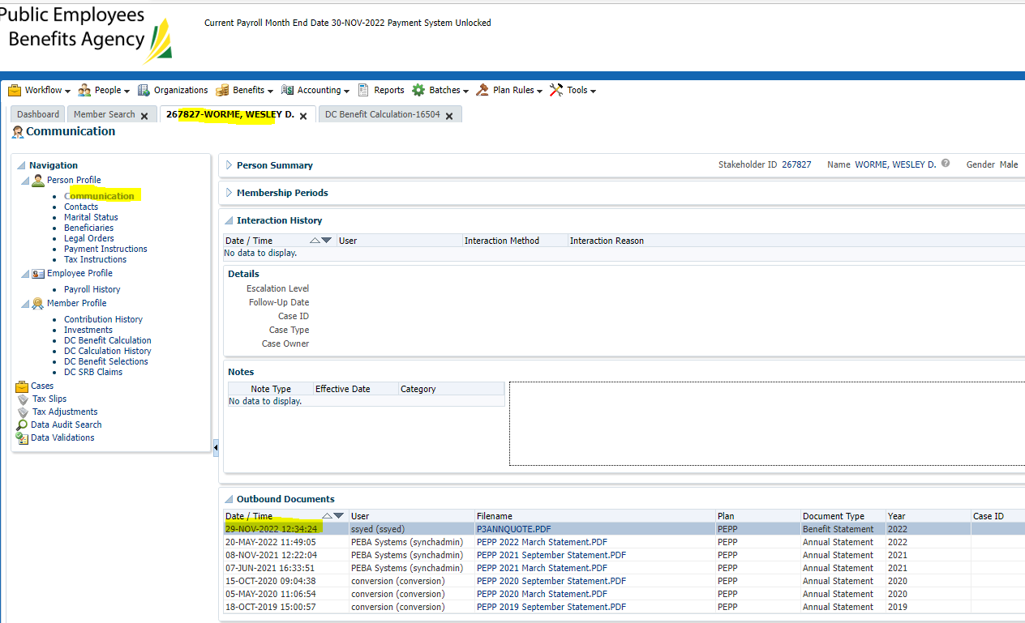

**Scenario 2: Single PEPP member, use override amount field**

SID 285178

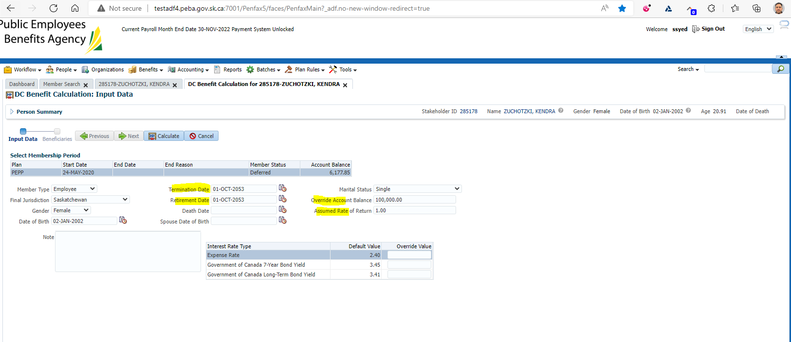

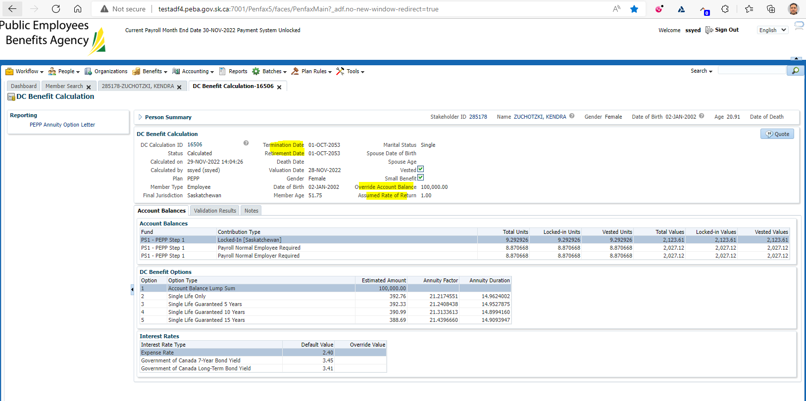**C**onfirmed that information entered is relayed correctly on this screen.

Estimated amount = override account balance $$

Checked that 1% ROR is NOT applied to the 100k

Letter generated correctly:

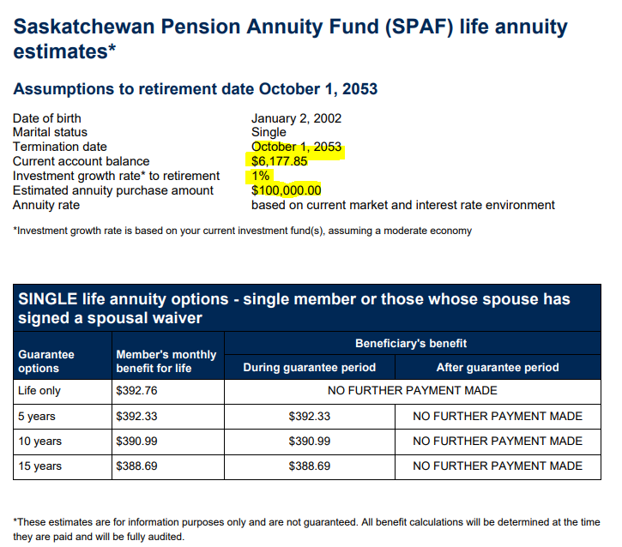

Checked to ensure quote was visible on PENWEB for member:

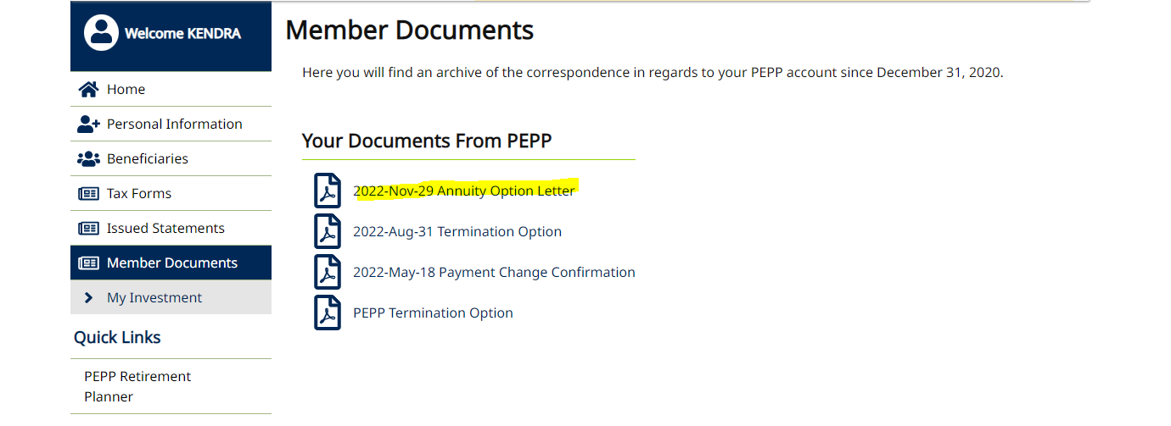

Verified and found letter is visible with the same information as expected.